Reduced Form Bioenergy Scenario Model
FY25 Q4 Technical Report

Executive Summary
This report presents a statistically rigorous reduced form modeling framework for the Bioenergy Scenario Model (BSM; Peterson et al., 2013), a large-scale system dynamics model developed by the National Renewable Energy Laboratory to evaluate the potential deployment of biofuels under a range of technological and policy conditions. The BSM produces hundreds of time series outputs from thousands of uncertain inputs, requiring millions of simulation runs to fully capture the system complexities. While this complexity enables rich scenario exploration, it renders classical global sensitivity analysis methods—such as Sobol indices or the Delta Moment-Independent Measure—computationally infeasible. It also creates computational and technical challenges for integration and large-scale studies.
To overcome these challenges, we developed a multi-stage statistical pipeline that balances fidelity, interpretability, and computational feasibility with accuracy. The workflow integrates regression-based screening with permutation null distributions, SHapley Additive exPlanations (Lundberg & Lee, 2017) based interaction detection, generalized additive model–based nonlinear transformation discovery, and penalized regression with Extended Bayesian Information Criterion (Chen & Chen, 2008) guided Least Absolute Shrinkage and Selection Operator (Tibshirani, 1996). The final reduced form model is estimated using unpenalized ordinary least squares (OLS; Seber 2012), which ensures unbiased coefficients, transparency, and reproducibility.
The reduced form model demonstrates strong fidelity to the full BSM: the final OLS-based model reduced error to 0.0445 normalized root mean square error. As shown in Figure ES1, predicted outputs align closely with full BSM trajectories across thousands of outputs and multiple decades. Residual and diagnostic analyses confirm the statistical soundness of the intermediate and final models.
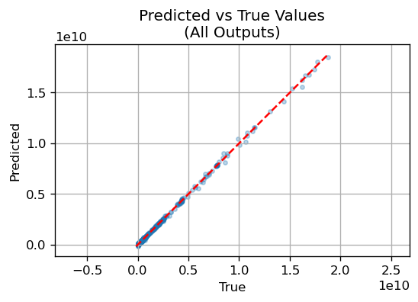
Figure ES1. Final ordinary least squares (OLS) reduced form model (Stage 3) predicted values versus true values directly from the full BSM (samples; N=15,000). The reduced form model demonstrates strong capabilities in reproducing each of approximately 25,000 outputs analyzed under this study.
The impact of this work is twofold. First, it provides the U.S. Department of Energy and stakeholders with a scalable and reproducible method for reducing the computational cost of analyzing complex energy system models, enabling more rapid exploration and scenario assessment. Second, it establishes a statistically rigorous template for reduced form modeling of other large-scale simulators in the energy and climate domains. By explicitly documenting selected predictors and outputs in Appendices A and B and publishing the final model coefficients, the reduced form model is fully transparent and reproducible, ready to be applied to ongoing analyses of incentive structures, system integration, and funding strategies.

1. Introduction
The Bioenergy Scenario Model (BSM; Peterson et al., 2013 is a large-scale system dynamics model developed by the National Renewable Energy Laboratory (NREL) to evaluate the deployment of biofuels across the U.S. energy system. The model integrates feedstock supply, conversion technologies, distribution infrastructure, and policy instruments, tracking both technological adoption and investment dynamics across multiple decades. The model contains over 240,000 unique elements, of which 8,900 are constants and 1,830 are lookup functions. Because the model represents both existing and emerging bioenergy industries, parameters surrounding technological performance, incentives, and market responses are uncertain.. Comprehensive exploration of this input space requires millions of runs, potentially generating over hundreds of terabytes or even petabytes of output data.
This scale poses a major challenge for uncertainty and sensitivity analysis and integrated modeling. Classical variance-based sensitivity analysis methods, such as Sobol indices (Sobol, 1993; Saltelli et al., 2010) and moment-independent measures such as the Delta Moment-Independent Measure (Borgonovo, 2007), are well established in the literature but require orders of magnitude more samples than can be feasibly managed. As a result, they are impractical for BSM-scale analyses. Though an individual model run-time is generally less than 1-minute, analysis requiring millions of runs requires years of compute time in serial. Additionally, the BSM is developed in proprietary software, challenging integration in other modeling environments.
To address this gap, we pursue a reduced form modeling approach. A reduced form model (RFM) is a statistical surrogate that approximates the input–output mapping of a complex simulator while retaining computational tractability and interpretability. Reduced forms have been used in integrated assessment and climate–energy modeling to enable analyses relevant to decision makers that would otherwise be infeasible (Trutnevyte et al., 2016; Dietz & Venmans, 2019; Pizer & Prest, 2020). However, prior reduced form approaches often rely on simplified statistical assumptions or ad hoc variable selection.
The objective of this work is to design and implement a rigorous, transparent workflow for constructing an RFM of the BSM that satisfies three criteria: accuracy, interpretability, and scalability. To achieve these goals, we developed a multi-stage statistical pipeline (described in Sections 3 - 5) that combines regression-based screening, SHapley Additive exPlanations (SHAP; Lundberg & Lee, 2017)-derived interaction discovery, nonlinear transformation detection, and penalized regression with de-biasing. The final reduced form model, constructed via ordinary least squares (OLS; Seber, 2012; Section 5), achieves high predictive accuracy while maintaining interpretability and reproducibility. Results are presented in Section 6, followed by conclusions (Section 7) and directions for future work (Section 8). Appendices A and B provide complete documentation of selected inputs and outputs.

2. Methods

2.1 Notation and Problem Setup
The BSM generates a large number of outputs across multiple decades and scenarios, conditioned on a high-dimensional set of uncertain inputs. Formally, we let n denote the number of simulation runs, k the number of candidate predictors, and p the number of scalar outputs. The predictors are collected into a design matrix
$$X ∈ R^{n×k}$$
while the outputs are collected into a response matrix
$$Y ∈ R^{n×p}$$
Each row corresponds to a simulation run, and each column of X represents one candidate predictor. Predictors fall into three categories:
- First-order inputs, corresponding to exogenous parameters in the BSM (e.g., technology adoption rates, incentive values).
- Second-order interactions, constructed as elementwise products $X_{a}×X_{b}$ for a ≠ b.
- Nonlinear transformations of first-order predictors, drawn from a library of simple transforms (quadratic, logarithmic, inverse, exponential).
Each column of Y corresponds to a scalar output: for example, annual production of a particular fuel in a particular year. There are many thousands of potential inputs and tuning parameters within the BSM; we restrict our input space to 158 scalar inputs and 2 binary variables (Appendix A) chosen using domain expertise. Across all outputs, the BSM the BSM can produce output for each of its 243,455 variables; we select 635 timeseries outputs (Appendix B), each with 37 annual values from 2015 to 2051, to produce a total of 23,495 scalar outputs under study. We deliberately choose to pursue classical methods rather than timeseries methods to maintain ease of downstream implementation of the final reduced form model and increase applicability to non-timeseries models.
Because the scale of model inputs varies widely (e.g., required rate of return vs progress ratio), input values are standardized to zero mean and unit variance. This step ensures that coefficients are directly comparable across predictors and that penalization methods such as Least Absolute Shrinkage and Selection Operator (LASSO; Tibshirani, 1996) apply equally across features (Hastie et al., 2009). Outputs are standardized when appropriate (e.g., before principal component analysis) to avoid dominance of high-variance outputs.
We tackle our problem of developing an RFM in 3 stages:
- Regression-based global sensitivity analysis for screening large effects
- Penalized regression for final feature selection
- OLS regression for final model development.
Linear regression is efficient at identifying linear relationships but has no native identification mechanism for interactions or non-linear effects. We thus first expand our input space to cover second-order interactions and non-linear transformations (Section 2.2). To then minimize the number of outputs required for testing, we systematically reduce the output space (Section 2.3).

2.2 Input Expansion

2.2.1 Interaction Discovery with SHAP Values
OLS regression captures only additive effects, even when the design matrix includes explicit pairwise products. To ensure that complex non-additive interactions are not missed, we independently quantify interactions using SHAP values.
To identify interactions, we turn to tree-based models. A tree-based model is a predictive algorithm that recursively partitions the input space into regions based on feature values, forming a decision tree where each leaf corresponds to a prediction (Breiman et al., 1984). Because tree-based models can only handle a single response variable at a time, we reduce the output space using principal component analysis (PCA; Jolliffe, 2002). PCA decomposes the standardized output matrix Y into orthogonal components ordered by variance explained. We retain the first 39 components, capturing 90% of the total variance, reducing dimensionality while preserving structure. Minimizing computational requirements is a key concern at this stage, thus we choose a relatively loose value of 90% variance retained.
For each component $l=1, …, 39$, we fit a gradient-boosted tree model (HistGradientBoostingRegressor; Pedregosa et al., 2011) to predict the component scores from X. Pairwise SHAP interaction values $ϕ_{an, l}^{int}$ are computed, measuring the contribution of joint dependence between predictors a and b. We aggregate interaction strength across components via an $l_{2}$ norm:
$${Φ^{int}}_{ab} = \sqrt{∑_{l=1}^{39} {({φ^{int}}_{ab,l}^{})}^{2}}$$
To separate genuine interactions from noise, we build a null distribution by permuting the PCA scores relative to X and recomputing SHAP interactions. To further minimize downstream computational demand, interactions exceeding the 99.5th percentile (a tight bound) of the null are retained ($α=0.005$). This procedure reduces ~25,600 candidate interactions to ~367 statistically exceptional pairs.

2.2.2 Nonlinear Transformation Detection with GAMs
While our predictor library includes simple nonlinear transformations, we employ generalized additive models (GAMs; Hastie & Tibshirani, 1990) to detect more general nonlinearities. For each first-order predictor X_{j} and each PCA score $S_{l}$, we fit
$$S_{l} = {β_{0}}_{l} + f_{jl}(X_{j}) + ε_{l}$$
where $f_{jl}$ is a smooth spline function. If the smooth term is statistically significant (p < 0.05), we approximate it using one of four parametric transforms:
- Quadratic: $X_{j}^{2}$
- Logarithmic: $log⁡(\left|X_{j}\right|+{10}^{-5})$
- Inverse: ${(|X}_{j}{\left|+{10}^{-5}\right)}^{-1}$
- Exponential: exp(X_{j})
where 10⁻⁵ is used for numerical stability.
The best-fitting transform is chosen as the one minimizing root mean squared error (RMSE):
$$RMSE(g) = \sqrt{(\frac{1}{n}) ∑_{i=1}^{n} {{S_{l}}_{i} - ({β_{0}}_{l} + ag({X_{j}}_{i}))}^{2}}$$
This yields 112 nonlinear transformations. The use of parametric approximations ensures that selected transformations are interpretable and portable across software platforms, a critical feature for integrated modeling applications.

2.3 Output Filtering
To avoid diluting the regression with uninformative outputs and to reduce computational burdens, we first filter outputs two ways:
- Near-zero variance filter. Any output Y_{m} with variance below 10⁻⁸ is removed. Such outputs typically correspond to structural zeros or deterministic artifacts of the BSM (e.g., early years before a technology has developed).
- Signal-to-noise ratio (SNR). For each output Y_{m}, we define:

$${SNR}_{m} = \frac{Var(Y_{m})}{E[{Y_{m}}^{2}] + {10}^{-10}}$$
with a small denominator adjustment for numerical stability. Outputs with SNR_{m} < 10⁻² are removed. This screening is motivated by the need to focus on outputs that vary meaningfully relative to their scale.
Having rigorously defined our input space and reduced our output space to non-trivial outputs, we begin Stage 1 with an OLS regression screening model.

3 Regression-Based Global Sensitivity Analysis
Global sensitivity analysis (GSA) traditionally seeks to apportion the variance of outputs to individual inputs and their interactions (Saltelli et al., 2010). Variance-based approaches such as Sobol indices (Sobol, 1993) or moment-independent measures such as the Delta Moment-Independent Measure (Borgonovo, 2007) provide rich quantification of influence but require extensive resampling of the input space. In the BSM, with hundreds of candidate inputs and more than 20,000 outputs, the computational cost of these approaches is prohibitive (Table 1), which at our scale would correspond to tens of millions of simulations and many terabytes of output data — infeasible in both compute and storage for most computational environments.
Method | Total model evaluations | Error convergence (MC) | Dependence on p | Typical N for stable results | Notes / references
Sobol’ indices (total effects + second order) | $\left(2p+2\right)N$ using Saltelli/Jansen design | $$O(\frac{1}{\sqrt{N}})$$ | Linear in p | $N∼{10}^{3}-{10}^{4}$ per input dimension | Standard variance-based method; second-order terms multiply cost (Saltelli et al., 2010)
Delta Moment-Independent Measure (Δ, single-loop/given-data) | N (all indices from same sample) | $O(\frac{1}{\sqrt{N}})$ (or better with KDE/smoothing) | Independent of p for model evaluations (post-processing scales with p) | $N∼{10}^{3}-{10}^{4}$ total | Captures distributional changes (Borgonovo, 2007; Plischke et al., 2013; Wei et al., 2013).
OLS regression-based | N (fit once on sample of size N) | Coefficient error scales as  $$O(\frac{1}{\sqrt{N}})$$ | Needs N≫p (rule of thumb: N≳10p) | $N∼{10}^{2}-{10}^{3}$N if p small; grows with dimensionality | Fast, linear scaling; limited to linear/additive effects unless extended with basis functions (Hastie et al. 2009)
Table 1. Estimate computational requirements of Sobol variance decomposition, Delta Moment Independent Measure, and OLS regression. Sobol indices provide valuable insight into the output variance but requires large sample sizes. The Delta Moment Independent Method can scale better than Sobol indices but requires expensive post-processing for analysis. OLS regression scales well with no post-processing requirements.
To address this, we employ regression-based GSA as an efficient alternative. Regression-based approaches approximate variance decompositions using the fitted coefficients of regression models (Hastie et al., 2009).
The general linear model is expressed as
$$Y = X β + ε$$
where $β∈ R^{k × p}$is the coefficient matrix mapping predictors to outputs, and $ε$ is the residual matrix. The multivariate OLS estimator is
$$\hat{β}= {(X^{T}X)}^{-1}{ X}^{T}Y$$
assuming $X^{T}X$ is invertible. When predictors are standardized, the magnitude of coefficients directly reflects their relative influence. To summarize influence across outputs, we compute row norms of $\hat{β}$:
${‖{\hat{β}}_{j·}^{}‖}^{2} = \sqrt{∑_{m=1}^{p} {{{\hat{β}}^{̂}}_{jm}}^{2}}$,
${\left\|{\hat{β}}_{j⋅}\right\|}_{∞}=\underset{m}{max⁡}|β_{jm}|$.
Regression-based screening is computationally efficient and analytically transparent, making it well suited for high-dimensional sensitivity analysis when variance-based methods are infeasible. Importantly, because our candidate feature set already includes explicit interactions and nonlinear transformations, linear regression coefficients indirectly capture much of the non-linear and complex structure present in the full-scale BSM.

3.1 Stage 1: Comprehensive OLS Screening with Permutation Null Distributions
The first stage of our workflow applies OLS regression across all candidate predictors (~26,560 features, including first-order, interaction, and nonlinear terms) to identify a broad set of potentially important features.

3.1.1 Null Distribution Construction
OLS coefficients can appear large even when predictors and outputs are unrelated, especially in high dimensions. To separate meaningful effects from spurious ones, we construct an empirical null distribution by permuting the association between predictors and outputs. Specifically, the rows of Y are permuted relative to X for B = 300,000 replicates. For each predictor j, the statistic
$$T_{j}^{(b)} = {‖{β^{̂}}_{j·}^{(b)}‖}^{2}$$
is computed, where ${\hat{β}}_{}^{\left(b\right)}$is the OLS coefficient matrix estimated on the permuted data. The observed statistic is
$T_{j}^{obs} = {‖{β^{̂}}_{j·}^{obs}‖}^{2}$.
Permutation p-values are then
$${\hat{p}}_{j}= \frac{1 + ∑_{b=1}^{B} 1\left(T_{j}^{\left(b\right)} ≥ T_{j}^{obs}\right)}{1 + B}$$

3.1.2 Multiple-Testing Correction
Because thousands of predictors are tested simultaneously, we control the false discovery rate (FDR) at q = 0.10 using the Benjamini–Hochberg procedure (Benjamini & Hochberg, 1995). This relatively liberal threshold reflects the role of this stage as screening rather than final selection: we prefer to include predictors that may ultimately prove unimportant rather than prematurely discarding those with true effects. The result of Stage 1 is a reduced predictor set ${\hat{S}}_{OLS}$that forms the input to subsequent stages. In our case, we retained 349 features at the end of this stage. Note the diagnostics described later (Section 4.4) were also applied here but are not described for brevity.

4 Stage 2 - Penalized Regression with LASSO
After screening and enrichment with SHAP and nonlinear transformations, the predictor set remains large. To isolate a parsimonious set of predictors, we apply the LASSO. For each reduced-dimension PCA score, LASSO solves
$$β^{̂} = {argmin}_{β} \{ \frac{1}{2n} {{‖S* - Xβ‖}^{2}}^{}+ α{‖β‖}^{1} \}$$
The $l_{1}$ penalty encourages sparsity, shrinking many coefficients to zero and retaining only the most relevant predictors.

4.1 Hyperparameter Selection via EBIC
The penalty parameter $α$ is chosen using the Extended Bayesian Information Criterion (EBIC; Chen & Chen, 2008):
$$EBIC = -2l\left(\hat{β}\right)+k_{act}\log{n} + 2γ\log{(C(k, k_{act}))}$$
where $l(\hat{β})$ is the log-likelihood of the fitted model, k_{act} is the number of active predictors, and $γ$ is a tuning parameter. We use $γ=0.5$, which balances fit against complexity in high-dimensional spaces.

4.2 Stability Selection
To ensure robust selection while minimizing computation, we assess stability across resampled subsets of data. We increase sample sizes and compute the Jaccard index (Jaccard, 1901) between predictor sets:
$$J(A, B) = \frac{|A ∩ B|}{|A ∪ B|}$$
We require Jaccard overlap > 0.75 and Spearman correlation of coefficient magnitudes > 0.9 across splits before accepting a sample size as adequate. This allows us to utilize a small (n=2000) sample size for the LASSO model, greatly reducing computational cost.

4.3 De-biasing and Statistical Inference
Because LASSO coefficients are biased toward zero, we apply nodewise LASSO (Meinshausen & Bühlmann, 2006) to estimate the inverse covariance matrix of predictors. This yields de-biased coefficient estimates with asymptotic normality (Zhang & Zhang, 2014; van de Geer et al., 2014). Hypothesis tests are conducted on de-biased coefficients, with multiple-testing correction using Benjamini–Hochberg False Discovery Rate (FDR) at 5%, a relatively modest FDR that allows for some amount of expected false positives. A stricter threshold may further reduce the input dimensionality but also risks eliminating valid inputs. This provides our final cut-off: coefficients that are non-zero across their 95% confidence intervals are retained while those with 0 in their 95% confidence intervals are discarded.

4.4 Diagnostics and Assessment
All model architectures come with certain assumptions- often assumptions about the samples or the errors. Statistical models, in particular, can have many assumptions. Linear regression requires independent and identically distributed samples and, for inference, normally distributed errors. We employ a rigorous diagnostic battery to evaluate the validity of modeling assumptions and to provide robustness where deviations were detected across outputs. Below we summarize the core diagnostics used and how they were interpreted in our workflow.
Residual Normality: We test whether standardized residuals follow a Gaussian distribution using Jarque-Bera (JB) test (Jarque and Bera, 1980). We corroborate formal tests with quantile–quantile (QQ) plots to diagnose tail departures and skew. Non‑significant statistics and near‑linear QQ plots support the normal‑errors assumption.
Robust Covariance: We test whether the conditional error variance changes with fitted values or regressors using Breusch–Pagan (Breusch & Pagan, 1979). Significant test statistics indicate non‑constant variance, which renders OLS standard errors unreliable if unaddressed. When heteroskedasticity is detected, we compute heteroskedasticity‑consistent covariance using HC3 (MacKinnon & White, 1985), which inflates standard errors for high‑leverage observations and yields more conservative finite‑sample inference than other methods (e.g., HC0/HC1; White, 1980; MacKinnon & White, 1985). We report coefficient estimates with HC3 standard errors and adjusted p‑values.
Simulation Independence: Sample independence is justified by Latin hypercube sampling (LHS; McKay et al., 1979), which stratifies each marginal input distribution, ensures broad coverage, and reduces correlation among samples. This design choice improves metamodel identifiability.
Approximate sparsity: Although many predictors exist, only a relatively small subset exerts practically significant effects; this motivates penalized regression (e.g., LASSO) and stability selection. We formalize this as ||β||₀ ≪ n (Wainwright, 2009).
Stationarity of mechanisms with mitigation: We assume input–output relationships are locally stable across the sampled domain. To mitigate deviations, we construct permutation‑based null distributions and require stability across resamples. Comparing observed statistics to the empirical null distinguishes genuine signals from artifacts of sampling variability or local non‑stationarity.

4.5 Intermediate Model Performance
The intermediate LASSO model showed strong performance, achieving a normalized root mean squared error (nRMSE; normalized by range) of 0.0859 and reducing our input space to 340 predictors, comprised of 62 unique first order inputs and their interactions or transformations.

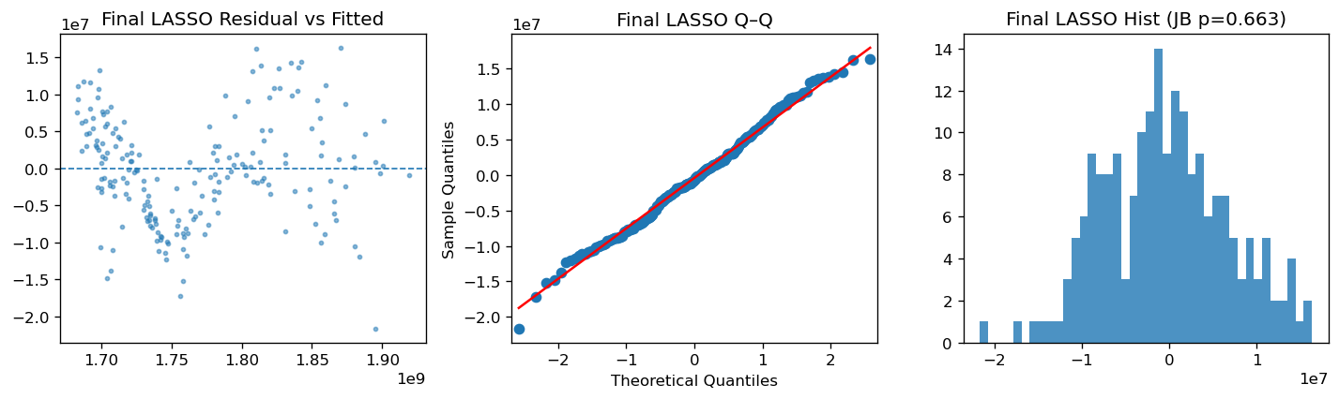
Figure X. Input-screening LASSO model diagnostics. We see a possible sinusoidal pattern in the residuals (panel A), suggesting additional non-linearities may be present. The QQ plot (panel B) demonstrates good fit with small deviations at the tails. Panel C provides further evidence of normally distributed residuals with a Jarque-Bera test p-value of 0.663.

5. Stage 3 - Reduced Form Model Construction
The culmination of the workflow described in Section 2 is the construction of the RFM, a statistically parsimonious surrogate that maps selected predictors to all outputs of the BSM. Unlike the intermediate feature-screening and penalized regression steps, the final reduced form is intentionally simple: an OLS regression applied to the final set of predictors. This choice is deliberate.
OLS is unbiased and efficient under the classical assumptions outlined in Section 2.7, and it produces coefficients that are immediately interpretable as marginal sensitivities. Unlike penalized regression approaches such as the LASSO, which shrink coefficients toward zero and require de-biasing to recover valid inference, OLS estimates are unpenalized and thus can be directly exported for integration into external workflows, and communication to stakeholders. The simplicity of OLS also supports reproducibility: any technical expert can replicate the final RFM using only the design matrix of selected predictors and the documented coefficients.
Formally, given the final selected predictor set S_{final} identified in Section 2, we solve:
$${\hat{β}}_{RFM}= argmin_{β}|| Y - X_{S_{final}} β |{\left.​\right|}_{F^{2}})$$
where $X_{S_{final}}$ denotes the subset of the design matrix restricted to predictors retained after OLS screening, SHAP-based interaction discovery, nonlinear transformation detection, and LASSO with EBIC-guided stability selection and de-biasing. The Frobenius norm aggregates squared errors across all outputs simultaneously. The resulting coefficient matrix ${\hat{β}}_{RFM}$provides the final mapping from inputs to outputs.
All predictors in S_{final} are listed in Appendix A (Table A1). This appendix serves as both a record of the variables deemed influential by our statistical workflow (Table A2) and as the basis for applying the reduced form model in practice.

3.1 Diagnostics
For the LASSO screening stage, we examined residual diagnostics to ensure that regression assumptions were not grossly violated and that selected predictors were statistically meaningful, following best practices for model selection and inference in high-dimensional settings (Hastie et al., 2015; Tibshirani, 1996). However, for the final reduced form OLS model, our objective is not coefficient inference but accurate prediction of outputs across the full input space. In this predictive setting, classical regression assumptions such as normally distributed residuals are not required for valid predictions (Shmueli, 2010). What matters is that the residuals are small relative to the scale of the outputs, which is reflected in our predictive performance metrics. Accordingly, we report only prediction-focused diagnostics for the final model (e.g., $R^{2}$, nRMSE, and predicted-vs-true plots; Figure 3), which demonstrate excellent agreement between model predictions and observed values. We also include residual plots to demonstrate basic OLS assumptions are met (Figure 2).
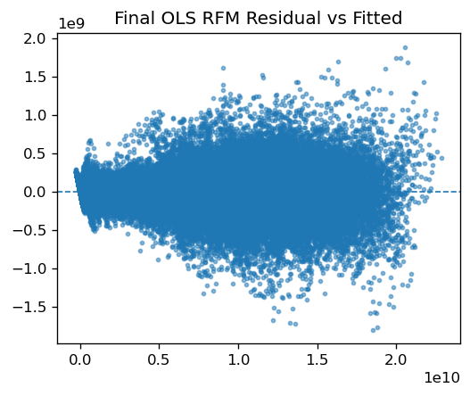
Figure 2. Residual analysis of the final (Stage 3) OLS model demonstrating random dispersion centered on zero.

6. Results

6.1 Predictive Accuracy
The performance of the RFM was evaluated on a holdout sample comprising 10% of the original BSM simulation runs. This sample was excluded from all stages of model training, including OLS screening, SHAP interaction detection, GAM nonlinear transformation identification, and penalized regression with EBIC-guided LASSO selection, to ensure that reported metrics reflect out-of-sample predictive accuracy.
The intermediate LASSO model (Section 4), which balances sparsity with predictive fidelity, achieved a nRMSE of 0.0859 across all outputs. After transferring the selected predictors into an unpenalized OLS framework (Section 5), the final reduced form achieved nRMSE of 0.0445. This reduction in error demonstrates the benefits of retaining predictors via LASSO but estimating coefficients via unbiased OLS.
The scatterplot of predicted versus true output values (Figure 3 shows tight clustering around the 45° line indicating that predictions track the BSM outputs with minimal bias. Deviations are small and symmetric, suggesting the absence of systematic over- or under-prediction. The high density of points along the diagonal reflects the model’s ability to generalize across the wide range of outputs produced by the BSM.
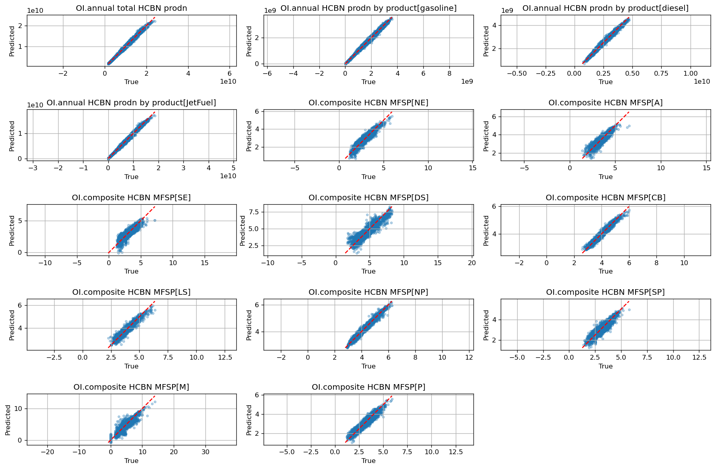
Figure 3. Scatterplots of the final OLS reduced form model (Stage 3) predictions versus true values from the full BSM for key outputs. Most outputs are tightly clustered around the line of perfection (red dashed line) nRMSE generally less than 0.04 and R² values from 0.893 to 0.997 indicating excellent performance across many outputs.

6.2 Time-Series Alignment
For selected outputs of policy and technological interest (e.g., annual production of hydrocarbon biofuels, biomass feedstock consumption rates, funding flows), predicted and true time-series trajectories align closely (Figure 4). The reduced form captures both short-term fluctuations and long-term trends, validating that the final model can represent dynamic trajectories, not only pointwise predictions. The preservation of temporal coherence is critical because many analyses depend on projected pathways rather than static snapshots.
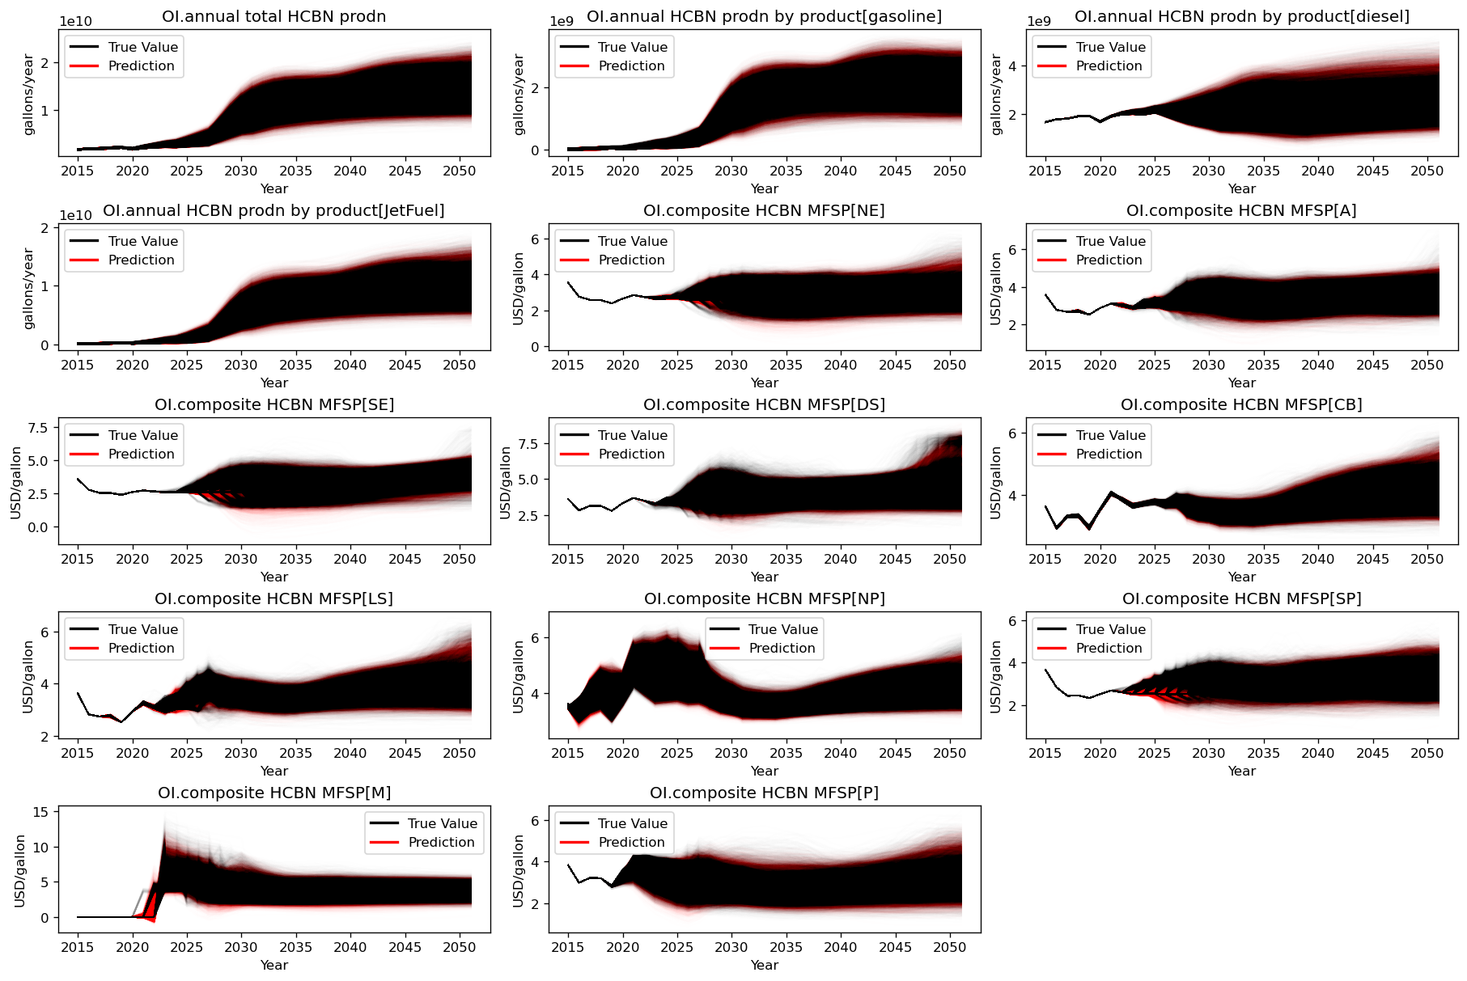
Figure 4. Timeseries plots of the final OLS reduced form model (Stage 3) predictions versus true values from the full BSM for key outputs. Outputs demonstrate strong alignment both in magnitude and over varying temporal patterns.

6.3 Analysis of Influential Inputs and Feature Structure
The global sensitivity analysis revealed a rich structure of influential inputs shaping outcomes in the BSM. Among the 340 influential features identified, 61 were first-order inputs, 242 were second-order interaction terms, and 37 were nonlinear transformations (Figure 5). Interactions thus outnumbered main effects by nearly four to one, and more than half of these interactions spanned multiple pathways rather than remaining confined within a single conversion technology. This dominance of cross-pathway effects highlights the central role of feedbacks between modules in driving system outcomes, a design principle that is core to the BSM’s internal representation of capital allocation, learning, and market signals across the biofuel supply chain (Peterson et al., 2015) and which are well documented in energy systems (e.g., Grübler et al., 1999; Wilson, 2012; Trutnevyte et al., 2016).
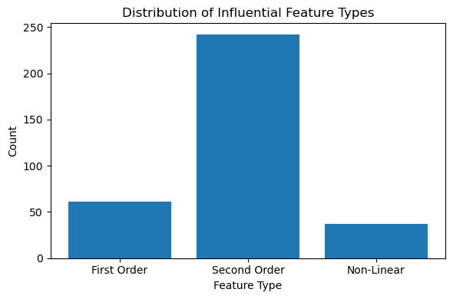
Figure 5. Distribution of influential inputs (those retained by both the Stage 1 OLS model and the Stage 2 LASSO model) by type. Second order interactions dominate (242), by a nearly 4:1 ratio against direct effects (first order features; 61). Non-linear features (37) were present (and almost always quadratic) but not as prevalent as the other feature types.
Influential features were discovered across the major modules of BSM (Figure 6), illustrating the complex network of inputs mapped to outputs exemplified by large-scale system dynamics models. Cellulosic hydrocarbons (CHC), algal hydrocarbons (AHC), oil crop/fats, oils, and greases (FOG) hydrocarbons (OHC), and starch ethanol to jet (SE) dominate, though the other modules have non-trivial counts as well.
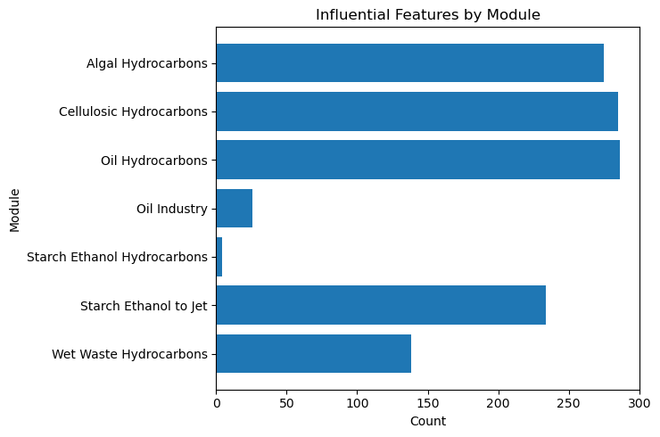
Figure 6. Distribution of influential inputs (those retained by both the Stage 1 OLS model and the Stage 2 LASSO model) by module. Features are well-distributed across modules, demonstrating the value of each module in the BSM design.
The interaction network is dense, (Figure 7) with significant numbers of interactions between all modules (Figure 8). Common linkages are found with process yields, industry rates of returns, and learning rates. These variables commonly interacted across most modules.
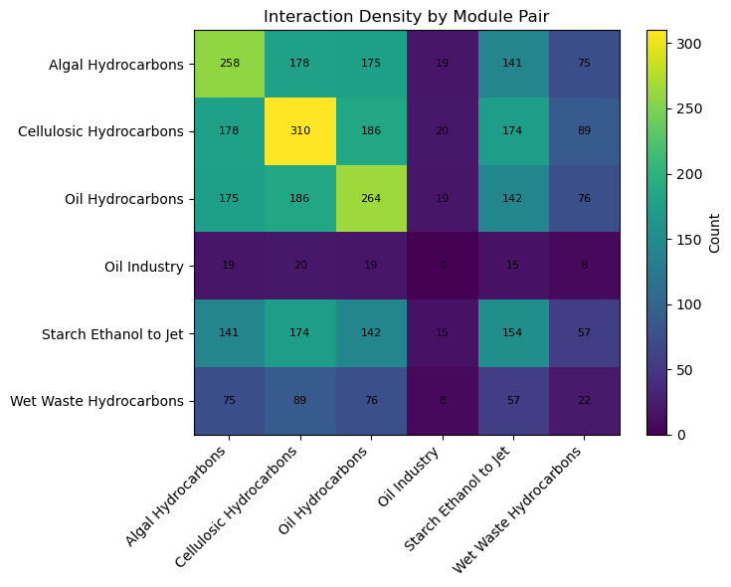
Figure 7. Heat map indicating density of interaction pairs among influential inputs. Interactions are often contained within a module, but significant interactions exist between modules.

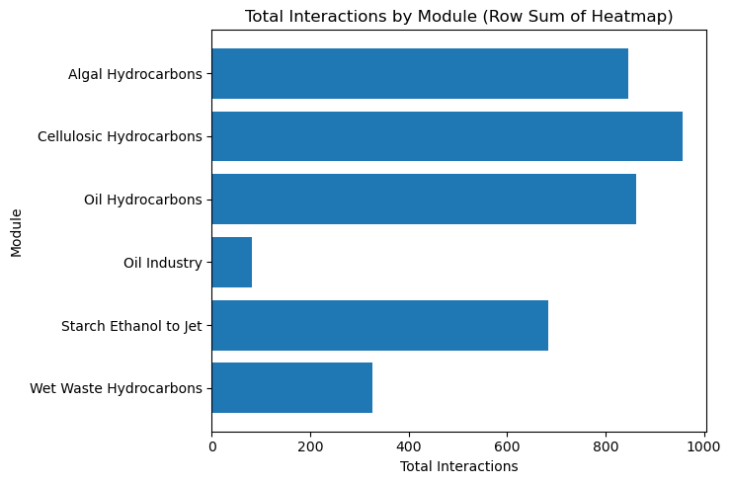
Figure 8. Total interactions by module. Large numbers of interactions are found across the BSM.
Within-pathway clustering was also evident. For CHC pathways, thermochemical variants dominated, with yields, ROR, and fixed capital investment (FCI) emerging as central drivers. In OHC pathways, hydro processed esters and fatty acids (HEFA) and HEFA-Brownfield yields exhibited the highest degree of connectivity, often appearing in interactions with both financial (e.g., ROR) and learning variables. For SJ pathways, the maximum jet investment hit rate was by far the most connected individual parameter, underscoring the importance of financial risk perceptions in investment decisions. These findings align with BSM’s structural emphasis on techno-economic analysis (TEA) parameters—particularly yields, returns, and capital costs—as levers that mediate adoption and investment feedbacks across pathways (Peterson et al., 2015; NREL, 2025).
At a higher level, yields emerged as the universal partner in interaction terms, most frequently coupling with RORs, FCIs, and learning parameters. This reflects BSM’s internal feedback loops, where conversion efficiency interacts with profitability, perceived investor risk, and the pace of cost reduction. Nonlinear features, though fewer in number, reinforced this pattern: thirty-five of the thirty-seven nonlinear terms were quadratic transformations, concentrated on financial and policy-related variables such as ROR, incentive durations, and yields. These nonlinearities are consistent with diminishing returns, threshold effects, and convexity embedded in BSM’s adoption and scale-up dynamics (Peterson et al., 2015).
Taken together, these results provide strong evidence that influential drivers in the BSM operate through coupled structures that span multiple pathways and modules, amplifying or moderating the effects of first-order inputs. The prominence of wet waste HTL as a hub for interactions underscores its systemic leverage. More broadly, the findings validate the BSM’s purpose as an integrative system dynamics model: rather than reducing to a set of independent pathway analyses, the model captures the interdependence of technologies, capital markets, and policy interventions that ultimately determine biofuel deployment trajectories (Peterson et al., 2015; NREL, 2025).

7. Conclusions
The analysis presented in this report demonstrates the feasibility of constructing a RFM of the BSM that is both statistically rigorous and computationally efficient. By integrating OLS screening, permutation-based null distributions, SHAP-derived interaction discovery, nonlinear transformation detection via generalized additive models, and EBIC-guided LASSO with de-biasing, we isolate a parsimonious set of predictors that faithfully reproduce the high-dimensional outputs of the BSM.
The final OLS-based reduced form utilized 340 inputs derived from 62 first order inputs. It achieved nRMSE of 0.0445 on a holdout dataset. Scatterplots of predicted versus observed outputs (Figure 3) and time-series trajectories (Figure 4) illustrate close alignment across thousands of outputs and multiple decades, confirming that the RFM reproduces both cross-sectional variability and temporal dynamics.
Equally important, the statistical framework ensures that predictor selection is robust to spurious correlations and multiple testing. Permutation nulls control finite-sample biases; false discovery rate adjustments balance Type I and Type II error risks; and stability analyses confirm reproducibility of predictor sets. Diagnostics applied to the final OLS fit—including residual analysis, normality checks, and heteroskedasticity tests—support the validity of the linear assumptions required for inference.
From a modeling perspective, the RFM provides several advantages. It dramatically reduces computational requirements, enabling sensitivity analyses, and scenario explorations to be performed at scale without rerunning the full system dynamics model. The use of OLS in the final step ensures interpretability and transparency, which are critical in input variable settings where reproducibility and clarity often outweigh marginal gains in predictive accuracy.
In summary, the reduced form approach presented here rigorously bridges the complexity of the BSM with the practical need for tractable surrogate models. By combining modern high-dimensional statistics with careful diagnostic validation, we achieve a surrogate that is accurate, interpretable, and reproducible, laying the foundation for broader application of reduced form methods in large-scale energy system modeling.

8. Future Work
While the RFM presented here demonstrates strong performance and interpretability, several limitations remain, and future work should focus on extending the methodology to address them.
First, although our workflow integrates nonlinear transformations and interaction detection, it ultimately relies on a linear reduced form estimated via OLS. This choice maximizes interpretability but cannot capture higher-order nonlinearities or structural feedbacks inherent in system dynamics models. Nonlinear surrogates such as Gaussian processes (Rasmussen & Williams, 2006) or neural-network-based emulators (Hewitt et al., 2020) have been successfully applied in other energy system contexts and may offer complementary accuracy gains. However, these methods sacrifice transparency and increase computational complexity, which is why we prioritized OLS in this work. A promising direction is to hybridize linear reduced forms with nonlinear corrections, as demonstrated in climate–economy modeling (Castruccio et al., 2014).
Second, our screening and selection process is computationally intensive, particularly the permutation-based null distributions that required 300,000 replicates. Although justified to ensure rigorous control of false discoveries, this step could be optimized using approximate null generation methods such as knockoffs (Candès et al., 2018) or Bayesian hierarchical shrinkage (Polson & Scott, 2012), which offer theoretically grounded alternatives at reduced cost.
Third, the reduced form’s ability to generalize is limited by the sampling design of the underlying BSM runs. Latin hypercube sampling provides good coverage of the input space but does not adaptively refine around regions of high sensitivity or nonlinearity. Adaptive sampling methods, such as sequential design strategies used in uncertainty quantification (Le Gratiet & Cannamela, 2015), could improve efficiency by allocating additional runs where surrogate error is highest. This has been shown to substantially reduce surrogate error in engineering design and could be directly translated to energy system modeling.
Fourth, our model assumes approximate sparsity, meaning that only a relatively small subset of predictors significantly influences outputs. While this assumption was borne out in practice, it may fail in contexts where weak but jointly important predictors accumulate to explain output variance. Ensemble-based methods, such as stability paths (Meinshausen & Bühlmann, 2010) or random forest–based sensitivity measures (Lundberg et al., 2020), could provide robustness in such settings by better capturing distributed weak signals.
Finally, the application of the RFM to analysis with variables, such as incentives, that can have finite durations requires further validation. While the surrogate replicates baseline BSM outputs with high fidelity, its ability to capture counterfactual shocks has not yet been tested. Previous studies of reduced forms in integrated assessment models (Dietz & Venmans, 2019; Pizer & Prest, 2020) highlight the risk that linear surrogates understate responses to discontinuous shocks or regime changes. Future research should therefore compare RFM outputs to BSM responses under out-of-sample scenarios to assess external validity.
In sum, the present work establishes a rigorous foundation for reduced form modeling of the BSM but also reveals opportunities for improvement. Future efforts should explore nonlinear surrogate classes, computationally efficient alternatives to permutation nulls, adaptive sampling, robustness to weak-signal predictors, and validation under novel scenarios. By pursuing these extensions, the reduced form framework can be made even more accurate, scalable, and relevant, further enhancing its role in decision support for complex energy system transitions.

References
Benjamini, Y., & Hochberg, Y. (1995). Controlling the false discovery rate: A practical and powerful approach to multiple testing. Journal of the Royal Statistical Society: Series B, 57(1), 289–300.
Borgonovo, E. (2007). A new uncertainty importance measure. Reliability Engineering & System Safety, 92(6), 771–784.
Breiman, L., Friedman, J. H., Olshen, R. A., & Stone, C. J. (1984). Classification and Regression Trees. Belmont, CA: Wadsworth International Group.
Breusch, T. S., & Pagan, A. R. (1979). A simple test for heteroscedasticity and random coefficient variation. Econometrica, 47(5), 1287–1294.
Candès, E., Fan, Y., Janson, L., & Lv, J. (2018). Panning for gold: ‘Model-X’ knockoffs for high-dimensional controlled variable selection. Journal of the Royal Statistical Society: Series B, 80(3), 551–577.
Castruccio, S., McInerney, D. J., Stein, M. L., Liu, C., Jacob, R. L., & Moyer, E. J. (2014). Statistical emulation of climate model projections based on a multivariate adaptive basis function approach. Journal of the American Statistical Association, 109(508), 1632–1647.
Chen, J., & Chen, Z. (2008). Extended Bayesian information criteria for model selection with large model spaces. Biometrika, 95(3), 759–771.
Cukier, R. I., Levine, H. B., & Shuler, K. E. (1973). Nonlinear sensitivity analysis of multiparameter model systems. Journal of Computational Physics, 26(1), 1–42.
Dietz, S., & Venmans, F. (2019). Cumulative carbon emissions and economic policy: In search of general principles. Journal of Environmental Economics and Management, 96, 108–129.
Grübler, A., Nakicenovic, N., & Victor, D. G. (1999). Dynamics of energy technologies and global change. Energy Policy, 27(5), 247–280.
Hastie, T., Tibshirani, R., & Friedman, J. (2009). The Elements of Statistical Learning (2nd ed.). Springer.
Hewitt, C., Smith, T., & Wilson, C. (2020). Emulating complex energy system models with machine learning. Applied Energy, 271, 115237.
Jaccard, P. (1901). Étude comparative de la distribution florale dans une portion des Alpes et du Jura. Bulletin de la Société Vaudoise des Sciences Naturelles, 37, 547–579.
Jarque, C. M., & Bera, A. K. (1980). Efficient tests for normality, homoscedasticity and serial independence of regression residuals. Economics Letters, 6(3), 255–259.
Jolliffe, I. T. (2002). Principal Component Analysis (2nd ed.). Springer.
Le Gratiet, L., & Cannamela, C. (2015). A Bayesian approach for global sensitivity analysis of (multi-fidelity) computer codes. SIAM/ASA Journal on Uncertainty Quantification, 3(1), 998–1023.
Lundberg, S. M., & Lee, S.-I. (2017). A unified approach to interpreting model predictions. In Advances in Neural Information Processing Systems (NeurIPS).
Lundberg, S. M., Erion, G., Chen, H., DeGrave, A., Prutkin, J. M., Nair, B., Katz, R., Himmelfarb, J., Bansal, N., & Lee, S.-I. (2020). From local explanations to global understanding with explainable AI for trees. Nature Machine Intelligence, 2(1), 2522–5839.
MacKinnon, J. G., & White, H. (1985). Some heteroskedasticity-consistent covariance matrix estimators with improved finite sample properties. Journal of Econometrics, 29(3), 305–325.
McKay, M. D., Beckman, R. J., & Conover, W. J. (1979). A comparison of three methods for selecting values of input variables in the analysis of output from a computer code. Technometrics, 21(2), 239–245. https://doi.org/10.1080/00401706.1979.10489755
Meinshausen, N., & Bühlmann, P. (2006). High-dimensional graphs and variable selection with the lasso. Annals of Statistics, 34(3), 1436–1462.
Meinshausen, N., & Bühlmann, P. (2010). Stability selection. Journal of the Royal Statistical Society: Series B, 72(4), 417–473.
NREL. Bioenergy Scenario Model (BSM). https://www.nrel.gov/bioenergy/bsm.html, 2025.
Pedregosa, F., et al. (2011). Scikit-learn: Machine learning in Python. Journal of Machine Learning Research, 12, 2825–2830.
Peterson S, Newes E, Inman D, et al. (2013). An Overview of the Biomass Scenario Model. In: The 31st International Conference of the System Dynamics Society. Cambridge, Massachusetts, http://www.systemdynamics.org/conferences/2013/proceed/papers/P1352.pdf.
Pizer, W. A., & Prest, B. C. (2020). Reducing emissions from the electricity sector: Lessons from market-based policies. Review of Environmental Economics and Policy, 14(1), 60–75.
Plischke, E., Borgonovo, E., & Smith, C. L. (2013). Global sensitivity measures from given data. European Journal of Operational Research, 226(3), 536–550.
Polson, N. G., & Scott, J. G. (2012). Local shrinkage rules, Lévy processes, and regularized regression. Journal of the Royal Statistical Society: Series B, 74(2), 287–311.
Rasmussen, C. E., & Williams, C. K. I. (2006). Gaussian Processes for Machine Learning. MIT Press.
Saltelli, A., Ratto, M., Andres, T., Campolongo, F., Cariboni, J., Gatelli, D., Saisana, M., & Tarantola, S. (2010). Global Sensitivity Analysis: The Primer. Wiley.
Seber, G. A. F., & Lee, A. J. (2012). Linear Regression Analysis (2nd ed.). Wiley.
Shmueli, G. (2010). To explain or to predict? Statistical Science, 25(3), 289–310.
Sobol, I. M. (1993). Sensitivity analysis for nonlinear mathematical models. Mathematical Modelling and Computational Experiments, 1(4), 407–414.
Sobol, I. M., & Kucherenko, S. (2009). Derivative based global sensitivity measures and their link with global sensitivity indices. Mathematics and Computers in Simulation, 79(10), 3009–3017.
Tibshirani, R. (1996). Regression shrinkage and selection via the lasso. Journal of the Royal Statistical Society: Series B, 58(1), 267–288.
Trutnevyte, E., Hirt, L. F., Bauer, N., Cherp, A., Hawkes, A., Edelenbosch, O. Y., Pedde, S., & van Vuuren, D. P. (2016). Societal transformations in models for energy and climate policy: The ambitious middle ground. Environmental Research Letters, 11(6), 064020.
van de Geer, S., Bühlmann, P., Ritov, Y., & Dezeure, R. (2014). On asymptotically optimal confidence regions and tests for high-dimensional models. The Annals of Statistics, 42(3), 1166–1202.
Wainwright, M. J. (2009). Sharp thresholds for high-dimensional and noisy sparsity recovery using ℓ1-constrained quadratic programming (Lasso). IEEE Transactions on Information Theory, 55(5), 2183–2202.
Wei, P., Lu, Z., & Yuan, X. (2013). Monte Carlo simulation for moment-independent sensitivity analysis. Reliability Engineering & System Safety, 110, 60–67.
White, H. (1980). "A Heteroskedasticity-Consistent Covariance Matrix Estimator and a Direct Test for Heteroskedasticity." Econometrica, 48(4), 817–838.
Wilson, C. (2012). Up-scaling, formative phases, and learning in the historical diffusion of energy technologies. Energy Policy, 50, 81–94.
Zhang, C.-H., & Zhang, S. S. (2014). Confidence intervals for low dimensional parameters in high dimensional linear models. Journal of the Royal Statistical Society: Series B, 76(1), 217–242.

Appendix A: Global Sensitivity Analysis Inputs and Influential Factors
First Order Input | Description | Pathway impacted | Minimum Sample Value | Maximum Sample Value | Units
AHC.Alt Price Sensi multiplier[HEFA] | Multiplier applied to 2024 value used for unit price incentive for fuels | Algal HEFA | 0.25 | 2 | unitless
AHC.Alt Price Sensi multiplier[HTL] |  | Algal HTL | 0.25 | 2 | unitless
AHC.Debt Interest Rate as pct[HEFA] | Interest rate of loan for FCI of conversion facility | Algal HEFA | 5 | 12 | %/yr
AHC.Debt Interest Rate as pct[HTL] | Interest rate of loan for FCI of conversion facility | Algal HTL | 5 | 12 | %/yr
AHC.FCI sensi multiplier[HEFA] | Multiplier that is applied to fixed capital investment cost for conversion facility | Algal HEFA | 0.75 | 1.25 | unitless
AHC.FCI sensi multiplier[HTL] |  | Algal HTL | 0.75 | 1.25 | unitless
AHC.FCI Background Subs[HEFA] | Sets fraction of FCI to be funded by external incentive | Algal HEFA | 0 | 0.5 | unitless
AHC.FCI Background Subs[HTL] | Sets fraction of FCI to be funded by external incentive | Algal HTL | 0 | 0.5 | unitless
AHC.FS Background Subs[HEFA] | Sets size of incentive that reduces delivered cost of feedstock | Algal HEFA | 0 | 50 | USD/ton
AHC.FS Background Subs[HTL] |  | Algal HTL | 0 | 50 | USD/ton
AHC.initial indices of Commercial Maturity[HEFA] | Sets initial value for commercial maturity for conversion pathway on 0-1 scale | Algal HEFA | 0.6 | 0.8 | unitless
AHC.initial indices of Commercial Maturity[HTL] |  | Algal HTL | 0 | 0.2 | unitless
AHC.Loan Guarantee Background Subs[HEFA] | Sets maximum fraction of FCI that is amenable to loan guarantee | Algal HEFA | 0 | 0.5 | unitless
AHC.Loan Guarantee Background Subs[HTL] |  | Algal HTL | 0 | 0.5 | unitless
AHC.Mature Industry Rate of Return as PCT[HEFA] | Sets required rate of return on investment for conversion facility. Used in calculation of net present value of prospective investment | Algal HEFA | 5 | 15 | %/yr
AHC.Mature Industry Rate of Return as PCT[HTL] |  | Algal HTL | 5 | 15 | %/yr
AHC.ORNOOC sensi multiplier[HEFA] | Multiplier applied to fixed operating cost, other (non-feedstock) operating costs, power sale credit, and other coproduct sale credit | Algal HEFA | 0.75 | 1.25 | unitless
AHC.ORNOOC sensi multiplier[HTL] |  | Algal HTL | 0.75 | 1.25 | unitless
AHC.Policy Duration[FCI,HEFA] | Sets duration of FCI incentive beginning with initial simulation year (2015) | Algal HEFA | 10 | 28 | year
AHC.Policy Duration[FCI,HTL] |  | Algal HTL | 10 | 28 | year
AHC.Policy Duration[Feedstock,HEFA] | Sets duration of Feedstock incentive beginning with initial simulation year (2015) | Algal HEFA | 10 | 28 | year
AHC.Policy Duration[Feedstock,HTL] |  | Algal HTL | 10 | 28 | year
AHC.Policy Duration[Loan,HEFA] | Sets duration of loan guarantee incentive beginning with initial simulation year (2015) | Algal HEFA | 10 | 28 | year
AHC.Policy Duration[Loan,HTL] |  | Algal HTL | 10 | 28 | year
AHC.Policy Duration[Price,HEFA] | Sets duration of unit price related incentive beginning with initial simulation year (2015) | Algal HEFA | 18 | 36 | year
AHC.Policy Duration[Price,HTL] |  | Algal HTL | 18 | 36 | year
AHC.progress ratios commercial[HEFA] | Sets rate at which each doubling of cumulative production impacts commercial maturity of conversion pathway | Algal HEFA | 0.65 | 0.85 | unitless
AHC.progress ratios commercial[HTL] |  | Algal HTL | 0.65 | 0.85 | 1/doubling
AHC.PY sensi multiplier[HEFA] | Multiplier applied to conversion process yield (i.e., gallons fuel per ton feedstock) | Algal HEFA | 0.75 | 1.25 | unitless
AHC.PY sensi multiplier[HTL] |  | Algal HTL | 0.75 | 1.25 | unitless
CHC.Alt Price Sensi multiplier[Biochem] | Multiplier applied to 2024 value used for unit price incentive for fuels | Cellulosic Biochem | 0.25 | 2 | unitless
CHC.Alt Price Sensi multiplier[Brownfield] |  | Cellulosic Thermochem (Brownfield) | 0 | 2 | unitless
CHC.Alt Price Sensi multiplier[Thermochem] |  | Cellulosic Thermochem | 0.25 | 2 | unitless
CHC.Debt Interest Rate as pct[Biochem] | Interest rate of loan for FCI of conversion facility | Cellulosic Biochem | 5 | 12 | %/yr
CHC.Debt Interest Rate as pct[Brownfield] | Interest rate of loan for FCI of conversion facility | Cellulosic Thermochem (Brownfield) | 5 | 12 | %/yr
CHC.Debt Interest Rate as pct[Thermochem] | Interest rate of loan for FCI of conversion facility | Cellulosic Thermochem | 5 | 12 | %/yr
CHC.FCI sensi multiplier[Biochem] | Multiplier that is applied to fixed capital investment cost for conversion facility | Cellulosic Biochem | 0.75 | 1.25 | unitless
CHC.FCI sensi multiplier[Brownfield] |  | Cellulosic Thermochem (Brownfield) | 0.75 | 1.25 | unitless
CHC.FCI sensi multiplier[Thermochem] |  | Cellulosic Thermochem | 0.75 | 1.25 | unitless
CHC.FCI Background Subs[Biochem] | Sets fraction of FCI to be funded by external incentive | Cellulosic Biochem | 0 | 0.5 | unitless
CHC.FCI Background Subs[Brownfield] | Sets fraction of FCI to be funded by external incentive | Cellulosic Thermochem (Brownfield) | 0 | 0.5 | unitless
CHC.FCI Background Subs[Thermochem] | Sets fraction of FCI to be funded by external incentive | Cellulosic Thermochem | 0 | 0.5 | unitless
CHC.FS Background Subs[Biochem] | Sets size of incentive that reduces delivered cost of feedstock | Cellulosic Biochem | 0 | 50 | USD/ton
CHC.FS Background Subs[Brownfield] |  | Cellulosic Thermochem (Brownfield) | 0 | 50 | USD/ton
CHC.FS Background Subs[Thermochem] |  | Cellulosic Thermochem | 0 | 50 | USD/ton
CHC.incremental scale up level[Biochem] | Sets maximum increment in conversion facility scale relative to nth plant TEA values | Cellulosic Biochem | 0 | 2 | unitless
CHC.incremental scale up level[Thermochem] |  | Cellulosic Thermochem | 0 | 2 | unitless
CHC.initial indices of Commercial Maturity[Biochem] | Sets initial value for commercial maturity for conversion pathway on 0-1 scale | Cellulosic Biochem | 0 | 0.2 | unitless
CHC.initial indices of Commercial Maturity[Brownfield] |  | Cellulosic Thermochem (Brownfield) | 0 | 0.7 | unitless
CHC.initial indices of Commercial Maturity[Thermochem] |  | Cellulosic Thermochem | 0.1 | 0.7 | unitless
CHC.Loan Guarantee Background Subs[Biochem] | Sets maximum fraction of FCI that is amenable to loan guarantee | Cellulosic Biochem | 0 | 0.5 | unitless
CHC.Loan Guarantee Background Subs[Brownfield] |  | Cellulosic Thermochem (Brownfield) | 0 | 0.5 | unitless
CHC.Loan Guarantee Background Subs[Thermochem] |  | Cellulosic Thermochem | 0 | 0.5 | unitless
CHC.Mature Industry Rate of Return as PCT[Biochem] | Sets required rate of return on investment for conversion facility. Used in calculation of net present value of prospective investment | Cellulosic Biochem | 5 | 15 | %/yr
CHC.Mature Industry Rate of Return as PCT[Brownfield] |  | Cellulosic Thermochem (Brownfield) | 5 | 15 | %/yr
CHC.Mature Industry Rate of Return as PCT[Thermochem] |  | Cellulosic Thermochem | 5 | 15 | %/yr
CHC.ORNOOC sensi multiplier[Biochem] | Multiplier applied to fixed operating cost, other (non-feedstock) operating costs, power sale credit, and other coproduct sale credit | Cellulosic Biochem | 0.75 | 1.25 | unitless
CHC.ORNOOC sensi multiplier[Brownfield] |  | Cellulosic Thermochem (Brownfield) | 0.75 | 1.25 | unitless
CHC.ORNOOC sensi multiplier[Thermochem] |  | Cellulosic Thermochem | 0.75 | 1.25 | unitless
CHC.Policy Duration[FCI,Biochem] | Sets duration of FCI incentive beginning with initial simulation year (2015) | Cellulosic Biochem | 10 | 28 | year
CHC.Policy Duration[FCI,Brownfield] |  | Cellulosic Thermochem (Brownfield) | 10 | 28 | year
CHC.Policy Duration[FCI,Thermochem] |  | Cellulosic Thermochem | 10 | 28 | year
CHC.Policy Duration[Feedstock,Biochem] | Sets duration of Feedstock incentive beginning with initial simulation year (2015) | Cellulosic Biochem | 10 | 28 | year
CHC.Policy Duration[Feedstock,Brownfield] |  | Cellulosic Thermochem (Brownfield) | 10 | 28 | year
CHC.Policy Duration[Feedstock,Thermochem] |  | Cellulosic Thermochem | 10 | 28 | year
CHC.Policy Duration[Loan,Biochem] | Sets duration of loan guarantee incentive beginning with initial simulation year (2015) | Cellulosic Biochem | 10 | 28 | year
CHC.Policy Duration[Loan,Brownfield] |  | Cellulosic Thermochem (Brownfield) | 10 | 28 | year
CHC.Policy Duration[Loan,Thermochem] |  | Cellulosic Thermochem | 10 | 28 | year
CHC.Policy Duration[Price,Biochem] | Sets duration of unit price related incentive beginning with initial simulation year (2015) | Cellulosic Biochem | 18 | 36 | year
CHC.Policy Duration[Price,Brownfield] |  | Cellulosic Thermochem (Brownfield) | 18 | 36 | year
CHC.Policy Duration[Price,Thermochem] |  | Cellulosic Thermochem | 18 | 36 | year
CHC.progress ratios commercial[Biochem] | Sets rate at which each doubling of cumulative production impacts commercial maturity of conversion pathway | Cellulosic Biochem | 0.65 | 0.85 | 1/doubling
CHC.progress ratios commercial[Brownfield] |  | Cellulosic Thermochem (Brownfield) | 0.65 | 0.85 | 1/doubling
CHC.progress ratios commercial[Thermochem] |  | Cellulosic Thermochem | 0.65 | 0.85 | 1/doubling
CHC.PY sensi multiplier[Biochem] | Multiplier applied to conversion process yield (i.e., gallons fuel per ton feedstock) | Cellulosic Biochem | 0.75 | 1.25 | unitless
CHC.PY sensi multiplier[Brownfield] |  | Cellulosic Thermochem (Brownfield) | 0.75 | 1.25 | unitless
CHC.PY sensi multiplier[Thermochem] |  | Cellulosic Thermochem | 0.75 | 1.25 | unitless
OHC.Alt Price Sensi multiplier[HEFA] | Multiplier applied to 2024 value used for unit price incentive for fuels | Oilcrop HEFA | 0.25 | 2 | unitless
OHC.Alt Price Sensi multiplier[HEFABrownfield] |  | Oilcrop HEFA (Brownfield) | 0.25 | 2 | unitless
OHC.Alt Price Sensi multiplier[TransEster] |  | Oilcrop Transesterification | 0 | 1 | unitless
OHC.Debt Interest Rate as pct[HEFA] | Interest rate of loan for FCI of conversion facility | Oilcrop HEFA | 5 | 12 | %/yr
OHC.Debt Interest Rate as pct[HEFABrownfield] | Interest rate of loan for FCI of conversion facility | Oilcrop HEFA (Brownfield) | 5 | 12 | %/yr
OHC.FCI sensi multiplier[HEFA] | Multiplier that is applied to fixed capital investment cost for conversion facility | Oilcrop HEFA | 0.75 | 1.25 | unitless
OHC.FCI sensi multiplier[HEFABrownfield] |  | Oilcrop HEFA (Brownfield) | 0.75 | 1.25 | unitless
OHC.FCI Background Subs[HEFA] | Sets fraction of FCI to be funded by external incentive | Oilcrop HEFA | 0 | 0.5 | unitless
OHC.FCI Background Subs[HEFABrownfield] | Sets fraction of FCI to be funded by external incentive | Oilcrop HEFA (Brownfield) | 0 | 0.5 | unitless
OHC.FS Background Subs[HEFA] | Sets size of incentive that reduces delivered cost of feedstock | Oilcrop HEFA | 0 | 50 | USD/ton
OHC.FS Background Subs[HEFABrownfield] |  | Oilcrop HEFA (Brownfield) | 0 | 50 | USD/ton
OHC.incremental scale up level[HEFA] | Sets maximum increment in conversion facility scale relative to nth plant TEA values | Oilcrop HEFA | 0 | 1 | unitless
OHC.initial indices of Commercial Maturity[HEFA] | Sets initial value for commercial maturity for conversion pathway on 0-1 scale | Oilcrop HEFA | 0.6 | 0.8 | unitless
OHC.initial indices of Commercial Maturity[HEFABrownfield] |  | Oilcrop HEFA (Brownfield) | 0.6 | 0.8 | unitless
OHC.Loan Guarantee Background Subs[HEFA] | Sets maximum fraction of FCI that is amenable to loan guarantee | Oilcrop HEFA | 0 | 0.5 | unitless
OHC.Loan Guarantee Background Subs[HEFABrownfield] |  | Oilcrop HEFA (Brownfield) | 0 | 0.5 | unitless
OHC.Mature Industry Rate of Return as PCT[HEFA] | Sets required rate of return on investment for conversion facility. Used in calculation of net present value of prospective investment | Oilcrop HEFA | 5 | 15 | %/yr
OHC.Mature Industry Rate of Return as PCT[HEFABrownfield] |  | Oilcrop HEFA (Brownfield) | 5 | 15 | %/yr
OHC.ORNOOC sensi multiplier[HEFA] | Multiplier applied to fixed operating cost, other (non-feedstock) operating costs, power sale credit, and other coproduct sale credit | Oilcrop HEFA | 0.75 | 1.25 | unitless
OHC.ORNOOC sensi multiplier[HEFABrownfield] |  | Oilcrop HEFA (Brownfield) | 0.75 | 1.25 | unitless
OHC.Policy Duration[FCI,HEFA] | Sets duration of FCI incentive beginning with initial simulation year (2015) | Oilcrop HEFA | 10 | 28 | year
OHC.Policy Duration[FCI,HEFABrownfield] |  | Oilcrop HEFA (Brownfield) | 10 | 28 | year
OHC.Policy Duration[Feedstock,HEFA] | Sets duration of Feedstock incentive beginning with initial simulation year (2015) | Oilcrop HEFA | 10 | 28 | year
OHC.Policy Duration[Feedstock,HEFABrownfield] |  | Oilcrop HEFA (Brownfield) | 10 | 28 | year
OHC.Policy Duration[Loan,HEFA] | Sets duration of loan guarantee incentive beginning with initial simulation year (2015) | Oilcrop HEFA | 10 | 28 | year
OHC.Policy Duration[Loan,HEFABrownfield] |  | Oilcrop HEFA (Brownfield) | 10 | 28 | year
OHC.Policy Duration[Price,HEFA] | Sets duration of unit price related incentive beginning with initial simulation year (2015) | Oilcrop HEFA | 18 | 36 | year
OHC.Policy Duration[Price,HEFABrownfield] |  | Oilcrop HEFA (Brownfield) | 18 | 36 | year
OHC.Policy Duration[Price,TransEster] |  | Oilcrop Transesterification | 18 | 36 | year
OHC.progress ratios commercial[HEFA] | Sets rate at which each doubling of cumulative production impacts commercial maturity of conversion pathway | Oilcrop HEFA | 0.65 | 0.85 | 1/doubling
OHC.progress ratios commercial[HEFABrownfield] |  | Oilcrop HEFA (Brownfield) | 0.65 | 0.85 | 1/doubling
OHC.PY sensi multiplier[HEFA] | Multiplier applied to conversion process yield (i.e., gallons fuel per ton feedstock) | Oilcrop HEFA | 0.75 | 1.25 | unitless
OHC.PY sensi multiplier[HEFABrownfield] |  | Oilcrop HEFA (Brownfield) | 0.75 | 1.25 | unitless
OHC.Retirement Frac[TransEster] |  | Oilcrop Transesterification | 0 | 0.15 | unitless
SE.Alt Price Sensi multiplier[EtOH] | Multiplier applied to 2024 value used for unit price incentive for fuels | Starch Ethanol | 0.25 | 1 | Unitless
SE.Alt Price Sensi multiplier[Jet] | Multiplier applied to 2024 value used for unit price incentive for fuels | Starch Ethanol-to-Jet | 0.25 | 2 | unitless
SE.Debt Interest Rate as pct[Jet] | Interest rate of loan for FCI of conversion facility | Starch Ethanol-to-Jet | 5 | 12 | %/yr
SE.FCI sensi multiplier[Jet] | Multiplier that is applied to fixed capital investment cost for conversion facility | Starch Ethanol-to-Jet | 0.75 | 1.25 | unitless
SE.FCI Background Subs[Jet] | Sets fraction of FCI to be funded by external incentive | Starch Ethanol-to-Jet | 0 | 0.5 | unitless
SE.FS Background Subs[Jet] | Sets size of incentive that reduces delivered cost of feedstock | Starch Ethanol-to-Jet | 0 | 50 | USD/ton
SE.initial indices of Commercial Maturity[Jet] | Sets initial value for commercial maturity for conversion pathway on 0-1 scale | Starch Ethanol-to-Jet | 0.1 | 0.5 | unitless
SE.Loan Guarantee Background Subs[Jet] | Sets maximum fraction of FCI that is amenable to loan guarantee | Starch Ethanol-to-Jet | 0 | 0.5 | unitless
SE.Mature Industry Rate of Return as PCT[Jet] | Sets required rate of return on investment for conversion facility. Used in calculation of net present value of prospective investment | Starch Ethanol-to-Jet | 5 | 15 | %/yr
SE.Max Jet Investment Hit Rate | Sets maximum potential rate of conversion of starch ethanol facilities to production of jet fuel | Starch Ethanol-to-Jet | 0.05 | 0.3 | 1/year
SE.ORNOOC sensi multiplier[Jet] | Multiplier applied to fixed operating cost, other (non-feedstock) operating costs, power sale credit, and other coproduct sale credit | Starch Ethanol-to-Jet | 0.75 | 1.25 | unitless
SE.Policy Duration[FCI,Jet] | Sets duration of FCI incentive beginning with initial simulation year (2015) | Starch Ethanol-to-Jet | 10 | 28 | year
SE.Policy Duration[Feedstock,Jet] | Sets duration of Feedstock incentive beginning with initial simulation year (2015) | Starch Ethanol-to-Jet | 10 | 28 | year
SE.Policy Duration[Loan,Jet] | Sets duration of loan guarantee incentive beginning with initial simulation year (2015) | Starch Ethanol-to-Jet | 10 | 28 | year
SE.Policy Duration[Price,Jet] | Sets duration of unit price related incentive beginning with initial simulation year (2015) | Starch Ethanol-to-Jet | 18 | 36 | year
SE.progress ratios commercial[Jet] | Sets rate at which each doubling of cumulative production impacts commercial maturity of conversion pathway | Starch Ethanol-to-Jet | 0.65 | 0.85 | 1/doubling
SE.PY sensi multiplier[Jet] | Multiplier applied to conversion process yield (i.e., gallons fuel per ton feedstock) | Starch Ethanol-to-Jet | 0.75 | 1.25 | unitless
WW.Alt Price Sensi multiplier[ManureToHTL] | Multiplier applied to 2024 value used for unit price incentive for fuels | Manure HTL | 0.25 | 2 | unitless
WW.Alt Price Sensi multiplier[SludgeToHTL] |  | Sewage Sludge HTL | 0.25 | 2 | unitless
WW.Debt Interest Rate as pct[ManureToHTL] | Interest rate of loan for FCI of conversion facility | Manure HTL | 5 | 12 | %/yr
WW.Debt Interest Rate as pct[SludgeToHTL] | Interest rate of loan for FCI of conversion facility | Sewage Sludge HTL | 5 | 12 | %/yr
WW.FCI sensi multiplier[ManureToHTL] | Multiplier that is applied to fixed capital investment cost for conversion facility | Manure HTL | 0.75 | 1.25 | unitless
WW.FCI sensi multiplier[SludgeToHTL] |  | Sewage Sludge HTL | 0.75 | 1.25
WW.FCI Background Subs[ManureToHTL] | Sets fraction of FCI to be funded by external incentive | Manure HTL | 0 | 0.5 | unitless
WW.FCI Background Subs[SludgeToHTL] | Sets fraction of FCI to be funded by external incentive | Sewage Sludge HTL | 0 | 0.5 | unitless
WW.FS Background Subs[ManureToHTL] | Sets size of incentive that reduces delivered cost of feedstock | Manure HTL | 0 | 50 | USD/ton
WW.FS Background Subs[SludgeToHTL] |  | Sewage Sludge HTL | 0 | 50 | USD/ton
WW.initial indices of Commercial Maturity[ManureToHTL] | Sets initial value for commercial maturity for conversion pathway on 0-1 scale | Manure HTL | 0 | 0.2 | Unitless
WW.initial indices of Commercial Maturity[SludgeToHTL] |  | Sewage Sludge HTL | 0 | 0.2 | Unitless
WW.Loan Guarantee Background Subs[ManureToHTL] | Sets maximum fraction of FCI that is amenable to loan guarantee | Manure HTL | 0 | 0.5 | unitless
WW.Loan Guarantee Background Subs[SludgeToHTL] |  | Sewage Sludge HTL | 0 | 0.5 | unitless
WW.Mature Industry Rate of Return as PCT[ManureToHTL] | Sets required rate of return on investment for conversion facility. Used in calculation of net present value of prospective investment | Manure HTL | 5 | 15 | %/yr
WW.Mature Industry Rate of Return as PCT[SludgeToHTL] |  | Sewage Sludge HTL | 5 | 15 | %/yr
WW.ORNOOC sensi multiplier[ManureToHTL] | Multiplier applied to fixed operating cost, other (non-feedstock) operating costs, power sale credit, and other coproduct sale credit | Manure HTL | 0.75 | 1.25 | unitless
WW.ORNOOC sensi multiplier[SludgeToHTL] |  | Sewage Sludge HTL | 0.75 | 1.25 | unitless
WW.Policy Duration[FCI,ManureToHTL] | Sets duration of FCI incentive beginning with initial simulation year (2015) | Manure HTL | 10 | 28 | year
WW.Policy Duration[FCI,SludgeToHTL] |  | Sewage Sludge HTL | 10 | 28 | year
WW.Policy Duration[Feedstock,ManureToHTL] | Sets duration of Feedstock cost incentive beginning with initial simulation year (2015) | Manure HTL | 10 | 28 | year
WW.Policy Duration[Feedstock,SludgeToHTL] |  | Sewage Sludge HTL | 10 | 28 | year
WW.Policy Duration[Loan,ManureToHTL] | Sets duration of loan guarantee incentive beginning with initial simulation year (2015) | Manure HTL | 10 | 28 | year
WW.Policy Duration[Loan,SludgeToHTL] |  | Sewage Sludge HTL | 10 | 28 | year
WW.Policy Duration[Price,ManureToHTL] | Sets duration of unit price related incentive beginning with initial simulation year (2015) | Manure HTL | 18 | 36 | year
WW.Policy Duration[Price,SludgeToHTL] |  | Sewage Sludge HTL | 18 | 36 | year
WW.progress ratios commercial[ManureToHTL] | Sets rate at which each doubling of cumulative production impacts commercial maturity of conversion pathway | Manure HTL | 0.65 | 0.85 | 1/doubling
WW.progress ratios commercial[SludgeToHTL] |  | Sewage Sludge HTL | 0.65 | 0.85 | 1/doubling
WW.PY sensi multiplier[ManureToHTL] | Multiplier applied to conversion process yield (i.e., gallons fuel per ton feedstock) | Manure HTL | 0.75 | 1.25 | unitless
WW.PY sensi multiplier[SludgeToHTL] |  | Sewage Sludge HTL | 0.75 | 1.25 | unitless
FM.Use Agnostic FS Conversion | Binary switch. Agnostic Herbaceous and Woody feedstocks usable by all processes. Target Herbaceous to Biochem, Woody to Thermochem | Applies to Cellulosic Hydrocarbons | Binary flags (0= off; 1 = on)* |  | unitless
OI.Use AEO Reference Oil | Switch to use AEO reference vs high projection for oil price | - |  |  | unitless
Table A1. Initial first order Inputs to the global sensitivity analysis screening ordinary. Each input was sampled using a Latin hypercube sampling design (McKay et al., 1979). Second order interactions were added as $X_{a}×X_{b}$ for each each pair of inputs where a $≠$ b. Non-linear transformations were also applied to each input creating a total input space of 26,560 potential inputs. *Binary inputs were treated as scenarios, where the remaining 158 inputs were sampled for each of four combinations of on/on, on/off, off/on, and off/off.

Input | Interaction Count | Transformation
AHC.Debt Interest Rate as pct[HEFA] | 1
AHC.FCI sensi multiplier[HEFA] | 2
AHC.FCI sensi multiplier[HTL] | 4
AHC.initial indices of Commercial Maturity[HEFA] | 0 | quadratic
AHC.initial indices of Commercial Maturity[HTL] | 4
AHC.Mature Industry Rate of Return as PCT[HEFA] | 2 | quadratic
AHC.Mature Industry Rate of Return as PCT[HTL] | 7 | inverse
AHC.ORNOOC sensi multiplier[HTL] | 2
AHC.PY sensi multiplier[HEFA] | 4 | quadratic
AHC.PY sensi multiplier[HTL] | 6 | inverse
CHC.Debt Interest Rate as pct[Thermochem] | 2
CHC.FCI sensi multiplier[Biochem] | 3
CHC.FCI sensi multiplier[Brownfield] | 6
CHC.FCI sensi multiplier[Thermochem] | 14
CHC.initial indices of Commercial Maturity[Biochem] | 3 | quadratic
CHC.initial indices of Commercial Maturity[Brownfield] | 12 | quadratic
CHC.initial indices of Commercial Maturity[Thermochem] | 15 | quadratic
CHC.Mature Industry Rate of Return as PCT[Biochem] | 3 | quadratic
CHC.Mature Industry Rate of Return as PCT[Brownfield] | 9 | quadratic
CHC.Mature Industry Rate of Return as PCT[Thermochem] | 19 | quadratic
CHC.progress ratios commercial[Brownfield] | 4
CHC.progress ratios commercial[Thermochem] | 13 | quadratic
CHC.PY sensi multiplier[Biochem] | 3 | quadratic
CHC.PY sensi multiplier[Brownfield] | 6
CHC.PY sensi multiplier[Thermochem] | 24 | quadratic
FM.Use Agnostic FS Conversion | 16
OHC.FCI sensi multiplier[HEFA] | 2
OHC.initial indices of Commercial Maturity[HEFA] | 0 | quadratic
OHC.initial indices of Commercial Maturity[HEFABrownfield] | 0 | quadratic
OHC.Mature Industry Rate of Return as PCT[HEFA] | 6
OHC.ORNOOC sensi multiplier[HEFA] | 3 | quadratic
OHC.ORNOOC sensi multiplier[HEFABrownfield] | 2 | quadratic
OHC.Policy Duration[Price,HEFA] | 2 | quadratic
OHC.Policy Duration[Price,HEFABrownfield] | 1
OHC.Policy Duration[Price,TransEster] | 0 | quadratic
OHC.progress ratios commercial[HEFA] | 7 | quadratic
OHC.progress ratios commercial[HEFABrownfield] | 1
OHC.PY sensi multiplier[HEFA] | 23 | quadratic
OHC.PY sensi multiplier[HEFABrownfield] | 22 | quadratic
OHC.Retirement Frac[TransEster] | 11 | quadratic
OI.Use AEO Reference Oil | 25
SE.FCI sensi multiplier[Jet] | 5
SE.initial indices of Commercial Maturity[Jet] | 3
SE.Mature Industry Rate of Return as PCT[Jet] | 6
SE.Max Jet Investment Hit Rate | 25 | quadratic
SE.ORNOOC sensi multiplier[Jet] | 3
SE.Policy Duration[Price,Jet] | 0 | quadratic
SE.progress ratios commercial[Jet] | 1 | quadratic
SE.PY sensi multiplier[Jet] | 12 | quadratic
WW.FCI sensi multiplier[ManureToHTL] | 5 | quadratic
WW.FCI sensi multiplier[SludgeToHTL] | 12 | quadratic
WW.initial indices of Commercial Maturity[ManureToHTL] | 4
WW.initial indices of Commercial Maturity[SludgeToHTL] | 5
WW.Mature Industry Rate of Return as PCT[ManureToHTL] | 11 | quadratic
WW.Mature Industry Rate of Return as PCT[SludgeToHTL] | 23 | quadratic
WW.ORNOOC sensi multiplier[ManureToHTL] | 6
WW.ORNOOC sensi multiplier[SludgeToHTL] | 15 | quadratic
WW.Policy Duration[Price,SludgeToHTL] | 0 | quadratic
WW.progress ratios commercial[ManureToHTL] | 2
WW.progress ratios commercial[SludgeToHTL] | 22 | quadratic
WW.PY sensi multiplier[ManureToHTL] | 12 | quadratic
WW.PY sensi multiplier[SludgeToHTL] | 23 | quadratic
Table A2. Influential Factors (First Order). Influential factors distilled to their first order level; that is, many of these become influential once expanded into interactions ($X_{a}×X_{b}$) and/or non-linear transformations. Full details of the final model (including the coefficient matrix) are available at https://www.nrel.gov/XX

Appendix B: Reduced Form Model Target Outputs
Variable | Description | Unit
AHC.MFSPMetric | Minimum Fuel Selling Price metric for algal fuels | USD/gal. Arrayed by conversion pathway and region
CHC.MFSPMetric | Minimum Fuel Selling Price metric for cellulosic fuels | USD/gal. Arrayed by conversion pathway and region
OHC.MFSPMetric | Minimum Fuel Selling Price metric for oilcrop and FOG-derived fuels | USD/gal. Arrayed by conversion pathway and region
OI.AHC output by product | Annual production of biofuels from algal feedstocks | Gal/yr. Arrayed by conversion pathway, region, and product (i.e., gasoline, diesel, jet)
OI.CHC output by product | Annual production of biofuels from cellulosic feedstocks | Gal/yr. Arrayed by conversion pathway, region, and product (i.e., gasoline, diesel, jet)
OI.OHC output by product | Annual production of biofuels from oilcrop and FOG feedstocks | Gal/yr. Arrayed by region and product (i.e., gasoline, jet)
OI.SJ output by product | Annual production of jet fuel from starch-ethanol | Gal/yr. Arrayed by conversion pathway, region, and product (i.e., gasoline, diesel, jet)
OI.WW output by product | Annual production of biofuels from wet waste feedstocks | Gal/yr. Arrayed by conversion pathway, region, and product (i.e., gasoline, diesel, jet)
OI.annual EtOH prodn by region | Annual production of ethanol from starch and cellulosic feedstocks | Gal/yr. Arrayed by region
OI.annual HCBN prodn by product | Total production of hydrocarbons from all conversion platforms | Gal/yr. Arrayed by product (i.e., gasoline, diesel, jet)
OI.annual total HCBN prodn | Total production of hydrocarbons. Sums production across platforms, products | Gal/yr. Scalar.
OI.composite EtOH CI | Composite metric for carbon intensity of ethanol from starch and cellulosic feedstocks | g/MJ. Arrayed by region and product (i.e., gasoline, diesel, jet)
OI.composite EtOH MFSP | Composite metric for minimum fuel selling price of ethanol from starch and cellulosic feedstocks | USD/gal. Arrayed by region.
OI.composite HCBN CI | Composite metric for carbon intensity of hydrocarbon fuels from all modeled hydrocarbon fuels | g/MJ. Arrayed by region and product (e.g., gasoline, diesel, jet)
OI.composite HCBN MFSP | Composite metric for minimum fuel selling price of hydrocarbons from all conversion platforms | USD/gal. Arrayed by region
SE.MFSPMetric | Metric for minimum fuel selling price of starch ethanol and ethanol-to-jet fuel | USD/gal. Arrayed by region, product (i.e., ethanol, jet fuel)
WW.MFSPMetric | Minimum Fuel Selling Price metric for wet waste-derived fuels | USD/gal. Arrayed by conversion pathway and region
Table B1. Reduced form model target outputs. When arrayed, these 17 outputs become 635 individual time series outputs with annual responses for years 2015 – 2051.

Appendix C: Model Description and Abbreviations.

Table C1. Model abbreviations.

We adopt a signal-to-noise ratio (SNR) criterion rather than the more commonly used coefficient of variation (CV) because our goal is to detect outputs that exhibit meaningful variability relative to their overall scale, not to assess proportional dispersion around a mean. The CV becomes unstable when means are near zero, whereas the SNR formulation remains well-defined due to its denominator adjustment and is directly interpretable as the ratio of variance to squared signal magnitude. To our knowledge, this exact form of output screening is novel, though it is motivated by related variance-based sensitivity analysis methods (Cukier et al., 1973; Sobol, 1993; Sobol & Kucherenko, 2009).
HEFA-brownfield represents integrating the HEFA process within existing petroleum refineries, leveraging existing infrastructure for a blended end product.

